  - <Logo>

  - <Organisation Name>

Monitoring & Evaluation Plan

9 March 2014

www.tools4dev.org
This template by tools4dev is licensed under a Creative Commons Attribution-ShareAlike 3.0 Unported License.
INSTRUCTIONS: Instructions for this template are shown in red and yellow. Delete all instructions before submitting your proposal.
Items to be completed are highlighted in grey. Remove the grey highlighting before submitting your proposal.

Contents
INSTRUCTIONS: Update the Table of Contents as the final step before submitting your report.
Acronyms ii
1 Introduction 1
1.1 Purpose of this plan 1
1.2 Project summary 1
2 Logical Framework 2
3 Indicators 3
4 Roles & Responsibilities 5
5 Data Flow 6
6 Data Management 7
6.1 Storage 7
6.2 Analysis 7
6.3 Privacy 7
Appendices 8
<Tool Title> 8
<Tool Title> 8
<Tool Title> 8

Acronyms
INSTRUCTIONS: Delete any acronyms that you do not use in your report. Add any additional acronyms that you use. Acronyms should ONLY be used for things that appear more than 15 times in your plan. If something appears less than 15 times it should be written out in full every time. The first time you use an acronym it should be written out in full with the acronym in parentheses afterwards.
AIDS Acquired Immunodeficiency Syndrome
HIV Human Immunodeficiency Virus
M&E Monitoring and Evaluation
MoH Ministry of Health
NGO Non-Governmental Organization
TOT Training of Trainers

Introduction
INSTRUCTIONS: Complete this section with background details.

Purpose of this plan
<Describe what the purpose of the monitoring and evaluation plan is, such as who prepared it, for which audience and why>

Organisation background
<Briefly describe the organisation and its vision and mission. This section is only necessary if the plan will be ready by people outside the organisation>

Projects
<Provide basic information on all the projects the organisation is running. Copy and past the following table as many times as necessary>
<Project 1 title>
Starting Date | <Insert>
Duration | <Insert>
Partners | <Insert>
Target Area | <Insert>
Beneficiaries | <Insert>
Cost | <Insert>
Funding Source | <Insert>
Goal | <Insert>

<Project 2 title>
Starting Date | <Insert>
Duration | <Insert>
Partners | <Insert>
Target Area | <Insert>
Beneficiaries | <Insert>
Cost | <Insert>
Funding Source | <Insert>
Goal | <Insert>

<Project 3 title>
Starting Date | <Insert>
Duration | <Insert>
Partners | <Insert>
Target Area | <Insert>
Beneficiaries | <Insert>
Cost | <Insert>
Funding Source | <Insert>
Goal | <Insert>

Logical Frameworks
INSTRUCTIONS: Complete the following logical framework table for each of your projects. The table should describe the goal, outcome, outputs and activities of the project. See the Logical Framework (Logframe) Template on tools4dev for an example of how to complete this table. Some sections may be similar between projects, for example if two projects have the same goal or indicators.

<Project 1 title>

 | PROJECT SUMMARY | INDICATORS | MEANS OF VERIFICATION | RISKS / ASSUMPTIONS
Goal | <Insert> | <Insert> | <Insert> | <Insert>
Outcomes | <Insert> | <Insert> | <Insert> | <Insert>
Outputs | <Insert> | <Insert> | <Insert> | <Insert>
Activities | <Insert> | <Insert> | <Insert> | <Insert>

<Project 2 title>

 | PROJECT SUMMARY | INDICATORS | MEANS OF VERIFICATION | RISKS / ASSUMPTIONS
Goal | <Insert> | <Insert> | <Insert> | <Insert>
Outcomes | <Insert> | <Insert> | <Insert> | <Insert>
Outputs | <Insert> | <Insert> | <Insert> | <Insert>
Activities | <Insert> | <Insert> | <Insert> | <Insert>

<Project 3 title>

 | PROJECT SUMMARY | INDICATORS | MEANS OF VERIFICATION | RISKS / ASSUMPTIONS
Goal | <Insert> | <Insert> | <Insert> | <Insert>
Outcomes | <Insert> | <Insert> | <Insert> | <Insert>
Outputs | <Insert> | <Insert> | <Insert> | <Insert>
Activities | <Insert> | <Insert> | <Insert> | <Insert>

Indicators
INSTRUCTIONS: For each indicator listed in the previous logframe tables describe precisely what the indicator is and how it will be measured. An example is shown below. Copy and paste the table as many times as required for completing all the indicators for all the projects. If two projects have the same indicator in both logframes you don’t need to describe the indicator twice in this section, only once.
Indicator | Reading proficiency among children in Grade 6
Definition | Sum of all reading proficiency test scores for all students in Grade 6 divided by the total number of students in Grade 6.
Purpose | To assess whether reading proficiency at the schools participating in the program is improving over time. This would provide evidence on whether the reading component of the program is effective.
Baseline | Average score: 47
Target | Average score: 57
Data Collection | The class teacher will conduct a reading proficiency test for all students in the class. Each student will be assessed individually in a separate room. The teacher will ask them to read a list of words, sentences and paragraphs out loud and will mark each one that they have difficulty with. Any students not present on the day of the assessment will be excluded.
Tool | National Reading Proficiency Assessment questionnaire (See Annex A)
Frequency | Every 6 months
Responsible | Teachers
Reporting | The individual score for each student will be reported in the six monthly progress reports submitted by each teacher to the Program Manager. The Program Manager will then combine the data from each class to create full list of students and their scores. This will be used to calculate the average score for all students in Grade 6 using the definition above. The average score will be included in the report for the donor submitted every six months.
Quality Control | All teachers will attend a one day training course on how to complete the assessment. To verify the accuracy of the test scores submitted by the teachers the Program Manager will randomly select one class every six months to audit. This audit will involve re-testing all the students in the class and comparing the results to the results submitted by the teacher.

Indicator | <Insert>
Definition | <Insert>
Purpose | <Insert>
Baseline | <Insert>
Target | <Insert>
Data Collection | <Insert>
Tool | <Insert>
Frequency | <Insert>
Responsible | <Insert>
Reporting | <Insert>
Quality Control | <Insert>

Roles & Responsibilities
INSTRUCTIONS: List each role in the organisation and their specific responsibilities for monitoring and evaluation. This may include collecting data, checking data, conducting analysis, reviewing reports, making decisions based on the data, etc. Some examples are shown below.

Role | Responsibilities
<Insert> | <Insert>
<Insert> | <Insert>
<Insert> | <Insert>
<Insert> | <Insert>
<Insert> | <Insert>
<Insert> | <Insert>
<Insert> | <Insert>
<Insert> | <Insert>

Data Flow
INSTRUCTIONS: Insert a flow chart and description showing how the monitoring data will flow from the place where it is collected up to the management team and then to other stakeholders, including the donor. An example is shown below.

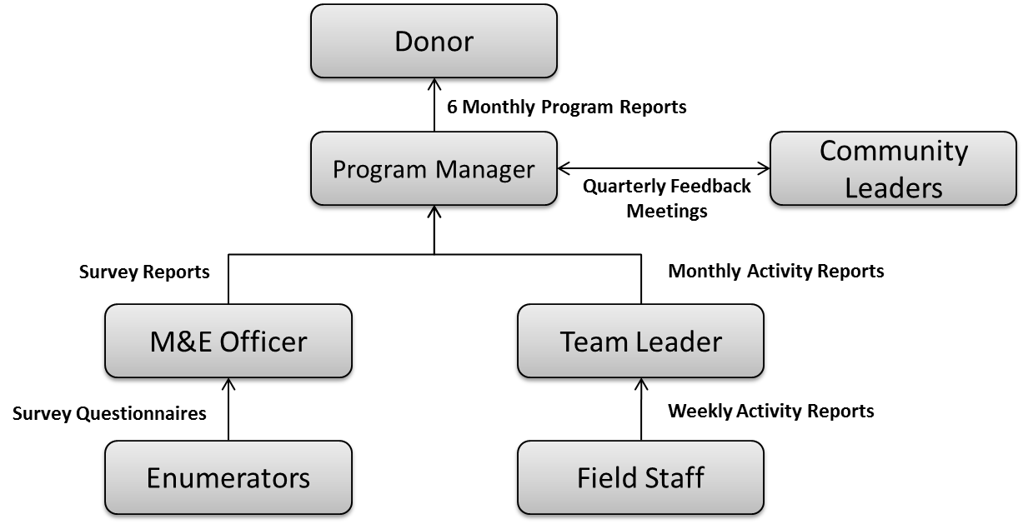
<Insert description of the data flow process>

Data Management

Storage
<Describe how the data collected will be stored. For example, will it be stored in a spread sheet, database, hard copies, etc. How will it be backed up? How long will it be stored for? Data for different indicators may be stored in different ways>

Analysis
<Describe which software / tools will be used to analyse the data, such as SPSS, Stata, Excel, Tableau Public, etc>

Privacy
<Discuss any privacy issues with the data and how they will be addressed. For example, if you are collecting personal medical records how will they be kept confidential, who will have access to them, when will they be destroyed, etc>

Appendices
INSTRUCTIONS: Add any necessary appendices. As a minimum this should include the tools (questionnaires, interview guides, procedures etc) that will be used to measure each indicator.

<Tool Title>
<Insert tool>

<Tool Title>
<Insert tool>

<Tool Title>
<Insert tool>

